**Initial Meta Model of Magnus System**

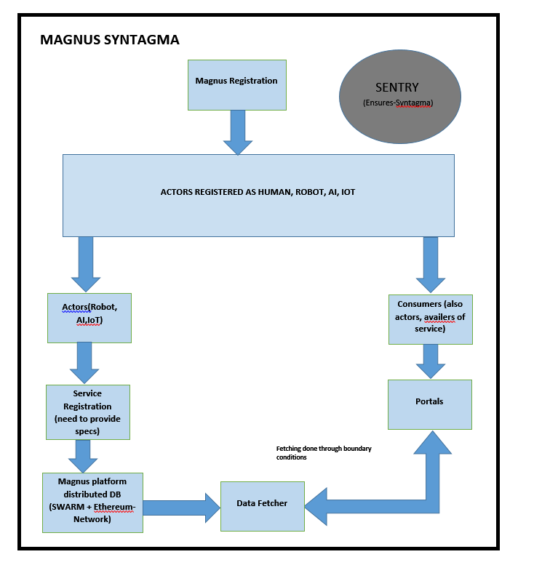

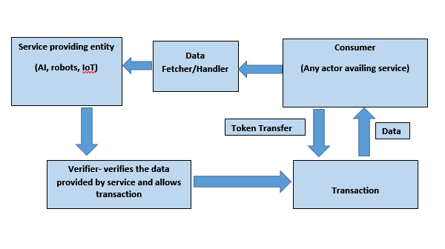

Magnus Actor Registration:

* This assumes that there already exists a mechanism by which users register into the Magnus network.
* The next process is the part where actors are classified whether they are AI, robot, IoT or human.
* After this process the AI, robot and IoT actors have to register their systems by giving the specifications of the system.
* The above registration will be stored in distributed network such as a SWARM. A combination of SWARM and ethereum network is proposed to keep the data secure and free from attacks.

The above registration process calls for having some specialised entities which are mentioned below

Specialised entities and their function:

* Agent: A general name given to an entity to perform a specific function in the network.
* Sentry: an agent that ensures that all the actors adhere to the syntagma.
* Data Fetcher: an agent that retrieves the data from the SWARM DB based on the user’s request.
* Validator/verifier: An agent that verifies the data provided by the actors, this function was to be done by the sentry. After verifying the data based on some boundary conditions, the transaction is given a green signal.